Suggestion on website

(as discussed in meeting on 19.7.2020)

* 1. Tabs should show active movement after touch of cursor. Where ever possible, add picture or icon along with name for presentation. – can be shown in html version
  2. Don’t add photo of merchant shipas it need special permission of company. Use same photos which are on old website. – done
  3. Line no 3 – tab corrections. done

First line –Notices and Events, Students corner, Gallery, Venders corner,Merit list, FAQ, Login, Contact Us, Follow Us

* 1. Notices and Events,

Notices and Events- New Tab. Three sub tabs on one page. can be shown in html version

1. Notices
2. News
3. Events
   1. Students Corner-
4. Students login - New sub tab.
5. Alumni - New sub tab.
6. Document verification. - New sub tab.
   1. Gallery -
7. Photo Gallery
8. Video Gallery
9. Students Testimonial
   1. Venders corner
10. Venders Registration Form
11. Venders Evaluation Forms
    1. Merit list – Page with information.
    2. FAQ -
12. Courses available in TSR.
13. Booking of course or admission in TSR.
14. Booking of Hostel in TSR.
15. Visit to TSR.
16. Procedure for Cancellation of course booking and fees refund. (**Cancellation and Fees Refund Policy.)**
17. Privacy Policy and Terms of Service of TSR. (**Privacy Policy and Terms of Service)**
18. Special instructions of all courses.
    1. Login
19. Faculty Login. Appex link.
20. Student Login. – only tab.
    1. Contact Us – Web site content.

Second line – Home, Foundation, Course Information, Post SeaOnline, Admission/Pre-SeaOnline, Room Booking

* 1. Home
  2. Foundation – all current tabs on your demo page.
  3. Course Information– Programmes / Courses - It is list of all course name with hyperlink to details. Remove all sub tabs. Add info page.
  4. Post Sea Course Booking - Add ‘Post sea online” link to it of old website. It is Appex software.
  5. Pre-Sea Course Booking /Admission– it is one tab. **Pre Sea and University Admission.** Add ‘Admission 2020” link to it of old website. It is Appex software.
  6. Room Booking – Page with information.

done

Third line - Colleges & Departments, Academic, Teaching Faculties, Library, NAAC, Feedback and Complaints,

Do changes as given in above line. done

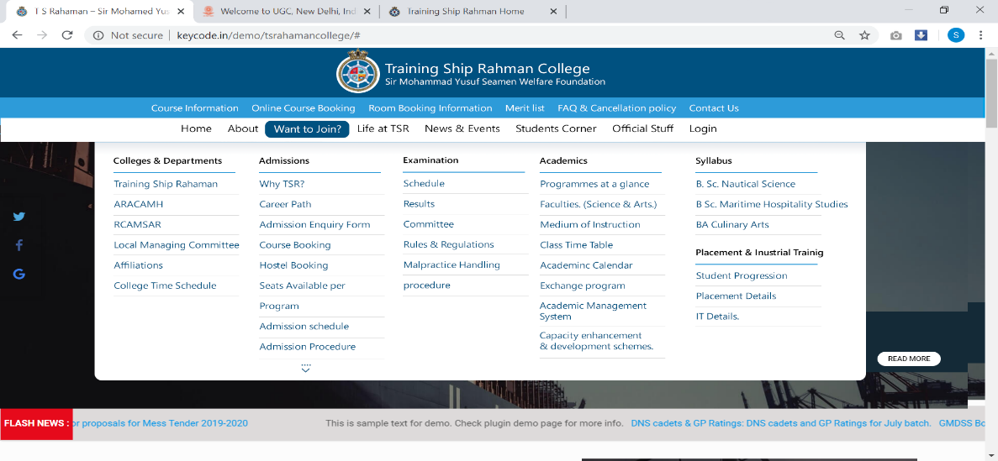

* 1. The Colleges & Departments can be shown in html version

1. TSR – old website page - <http://www.tsrahaman.org/tsr.html>
2. ARACAMH – old website page - <http://www.tsrahaman.org/aracah.html>
3. RCAMSAR – old website page - <http://www.tsrahaman.org/rcamsar.html>
4. College Infrastructure and Facilities
5. Committees and Associations – Add new tab.
6. Sports and Cultural events. - Add new sub tab.
7. Reports. – Add new tab.
8. Human Resource - Add new sub tab.
9. Application form for faculty – Rename as ‘Job Application’
10. Job vacancy list - Add info page.
11. Organisational Structure – Rename as “Governance and Administration”. Add info page.
12. Teaching Staff – Add info page.
13. Non-Teaching Staff – Add info page.
14. HRM Policy. - Add info page. (Password protected-only for NAAC presentation)
15. Leave Rules - Add info page. (Password protected-only for NAAC presentation)
16. Code of conduct - Add info page.
17. Act and Policies- Add info page.
    1. Academic
18. Admission
19. Why TSR?
20. Career Path – Add info page. with course list – give old website link of career path of each course.
21. Admission Enquiry Form – Add info page.
22. Course Booking – Link to Online course booking tab.
23. Hostel Booking – Add info page.
24. Seats Available Per Program – change to “Programs -Total Seats and Faculty”. Add info page.
25. Admission schedule - Add info page. . - Add ‘Admission 2020” link to it of old website. It is Appex software.
26. Admission Procedure - Add info page.
27. Fees Structures - Add info page.
28. Merit Lists - Link to Merit Lists tab.
29. Admission cancellation policy - Add info page.
30. Parent / Guardian Consent Form – Use link given in old website.
31. Undertaking by Parents / Legal Guardians - Use link given in old website.

1. Academic
2. Programmes at a glance - Add info page.
3. Medium of Instruction - Add info page.
4. Class Time table - Change to “College Time Schedule”
5. Research – Add new tab in academic and remove from main page.
6. Govt. & TSR Leave Calendar - Add new tab. Add info page.
7. Faculty Exchange Program - Add new tab.
8. Syllabus - Add new tab.
9. ICT - Add new tab.
10. PO’S CO’S and PSO’S- Add new tab.
11. Examination - Add info page.
12. Examination Committee
13. Examination rules and regulations
14. Examination Schedules.
15. Examination results.
16. Exam Reports
17. Placement and IT- Add info page.
    1. Teaching Faculties,

Teaching Faculties - Use old website data – ‘Faculty’.

* 1. Library

1. LibraryInformation
2. Total Collection
3. Library Timing.
4. Library services and facilities
5. Infrastructure and Learning Resources
6. Library Committee and Staff Details
7. Campus Roundabout
8. George Campbell Library Current Awareness Service
9. Competitive Examinations Centre
10. Important Links
    1. NAAC
11. Internal Quality Assurance Committee
12. Academic Audit Report
13. Meeting Details
14. Important Document Link
    1. Feedback and Complaints –
15. Feedback on students
16. Feedback on
17. Feedback on
18. Feedback on
    1. Flash News (Read all/Detail) – Done



Read all/Details

* 1. Brief history Not found in email

Add history given in email.

* 1. Our Courses –
  2. Administrative Services and Facilities –

Add all facilities which are important for NAAC.

Canteen hostel nss ncc library gymkhala sports

These are the NAAC recommended facilities – does TSRahaman have these facilities like NCC, NSS?

* 1. News and events reduce to 3 points. Already done
  2. News letter and For an enquiry which is on old website at last is missing in new template. Done